# Meeting 1 Notes: 6/8/18

<https://www.lucidchart.com/invitations/accept/6557347f-c50c-42f0-b50f-6711588a8249>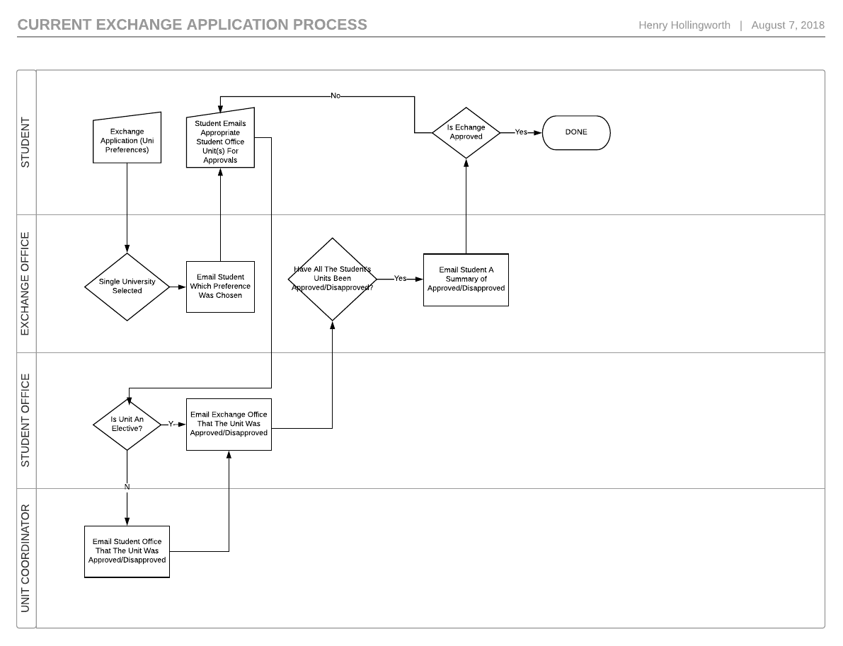

## Technology Involved

Interactions between the student, EO, SO occur via email but within the context of the askUWA system. Communication between the SO and the UC occurs outside of askUWA but via email. askUWA is an implementation of [Oracle RightNow](https://www.oracle.com/applications/rightnow/web-experience/web-self-service/). The students exchange application is handled by the EO in software called Global Studio (I cannot find a link to this software). Each SO (and potentially UC) have their own process of recording equivalent units - often in spreadsheets. Student and associated course/unit information is stored in Calista.

## Communication Matrix

|  |  |  |  |  |  |
| --- | --- | --- | --- | --- | --- |
|  | S E N D E R | | | | |
| R  E  C I  E  V E  R |  | Student | Exchange Office | Student Office | Unit Coordinator |
| Student |  | |  |  | | --- | --- | | askUWA | Sent from the askUWA system but showing up in their external email. | | N/A  *The SO shouldn’t be replying to the student’s email of units to be approved?* | N/A  *I can’t think of any circumstance in which the UC would talk directly to the Student.* |
| Exchange Office | |  |  | | --- | --- | | Email | Out of band communications may occur but they ultimately end up completing an application form via global studio. | | Application Form | Exchange Application form (Uni preferences) found on the user facing global studio site. | |  | |  |  | | --- | --- | | askUWA | The SO should alert the EO that a unit was approved/disapproved via sending an email via askUWA. | | Email | The SO could potentially send an email directly to the EO. | | *The UC would presumably be telling the SO (who sent them an email asking to approve a unit) who would in turn contact the EO but it isn’t implausible to think that the UC might contact the EO directly.*   |  |  | | --- | --- | | Email | UC could contact EO directly via an email external to askUWA. | |
| Student Office | |  |  | | --- | --- | | Email | The student after being told which Uni preference they were awarded externally (outside of askUWA) emails the SO with a list of units for approval. | | |  |  | | --- | --- | | askUWA | In the context of a particular students approvals the EO doesn’t communicate with the SO but if they happen to receive an email from the student they will “requeue” the email on askUWA. | |  | |  |  | | --- | --- | | Email | The UC will respond to the SO’s email (the SO’s email was sent external of askUWA) directly. | |
| Unit Coordinator | N/A | N/A | |  |  | | --- | --- | | Email | If the unit needs the UC’s approval the SO will send an external (outside of askUWA) email to them. | |  |

## 

## Communication Matrix Flow

When the above Communication Matrix is converted into a flow diagram we get the following:

|  |
| --- |
|  |

The proposed solution would alter this flow into the following:

|  |  |
| --- | --- |
|  | **Summary:**  The process of submitting an exchange application to the EO remains the same as it was before, however when it comes time to ask for unit approvals the student will fill in a ‘Request Unit Approval Form’ which gets processed by the CITS3200 project, it determined if each unit is already approved. If it is it emails the EO letting them know to update their exchange application in Global Studio.  If the units were not already approved the CITS3200 system will automatically email the appropriate SO with the relevant information included in the ‘Request Unit Approval Form’. When the SO exams the request if it is for an elective unit they may directly fill in the ‘Unit Approval Result Form’, if it is for a core or option unit they will forward or otherwise email the UC to have them appraise the unit. The UC will then submit the ‘Unit Approval Result Form’.  When the ‘Unit Approval Result Form’ is submitted the EO will be notified of the result, and (possibly) if all the units have been approved the student will be automatically notified via email. |

## Miscellaneous information

**Contacts for UWA current sytems:**

* AskUWA: Julie Millias
* Callista: Rebecca Ostegard
* Global Studio: Giulia Fabbris

**Ros (client) on leave:**

* 27th September - 23rd October
* Tash Glass to cover for Ros in that time

**Examples of other university systems:**

* North Eastern University
* University of Illinois study abroad site